BUSINESS PROCESS AND ANALYSIS [CASE STUDY: UBEREATS]

AND

MARKET BASKET ANALYSIS

BY

SHAW OLUWAGBOUNMI PRECIOUS

STUDENT ID: ST20182956

PROGRAM: Msc. DATA SCIENCE (INTERNSHIP)

COURSE: BUSINESS PROCESS AND DATA ANALYSIS

Table of Contents

List of Figures 3

TASK 1 4

1.0 INTRODUCTION 4

2.0 JUSTIFICATION OF TOOLS AND TECHNIQUES 4

3.0 STRATEGY ANALYSIS 5

3.1 MICHAEL PORTER FIVE FORCES MODEL 5

3.2 RESOURCE AUDIT 6

4.0 INVESTIGATE SITUATION 7

4.1 RICH PICTURE 7

4.2 DFD CONTEXT DIAGRAM 7

5.0 CONSIDER PERSPECTIVES 8

5.1 CATWOE ANALYSIS 8

5.2 POWER/INTEREST GRID 10

6.0 ANALYSE NEEDS 11

6.1 STRUCTURED ENGLISH 11

6.2 UML USE CASE DIAGRAM 12

6.2.1 USE CASE DESCRIPTION 14

7.0 DEFINE REQUIREMENTS 16

7.1 LEVEL 0 DFD DIAGRAM AND DESCRIPTION 16

7.2 LEVEL 1 DFD DIAGRAM AND DESCRIPTION 17

7.3 UML CLASS DIAGRAM 18

7.4 SEQUENCE DIAGRAM 19

8.0 OBSERVATIONS 19

9.0 EVALUATION 20

TASK 2 21

1.0 INTRODUCTION 21

1.1 ASSOCIATION RULE OF MARKET BASKET ANALYSIS 21

1.2 APRIORI ALGORITHM 21

1.3 PARAMETERS USED IN ASSOCIATION RULES 21

2.0 APPLICATION 22

3.0 CONCLUSION 22

REFERENCES 23

# List of Figures and Tables

Figure 1: Rich picture – Page 7

Figure 2: DFD Context Diagram – Page 8

Figure 3: Use Case Diagram – Page 12

Figure 4: Level 0 DFD Diagram – Page 15

Figure 5: Level 1 DFD Diagram for Process 1 – Page 16

Figure 6: Level 1 DFD Diagram for Process 2 – Page 16

Figure 7: Level 1 DFD Diagram for Process 3 – Page 17

Figure 8: UML Class Diagram – Page 17

Figure 9: Sequence Diagram – Page 18

Table 1: Michael’s Five Forces Model – Page 5

Table 2: CATWOE Analysis – Page 9

Table 3: Power/Interest Grid – Page 10

# TASK 1

## 1.0 INTRODUCTION

The world economy was exposed to a chain of challenges and menace as a result of COVID-19. (Altig et al. 2020). Most business were forced to either shut down or continuing running online.

Small sized restaurants which did not have an online presence had to shift to the online food industry as a result of the pandemic. The cost of building an application is high, thereby leading many restaurants to register with an online food ordering and delivery business as this will help them shoulder the cost of building their own application or software.

UberEats, a subsidiary of Uber Technologies was launched in United Kingdom in 2016 and since then has become of the thriving business in the online food ordering and delivery industry. UberEats provides a platform for their customers to order food at their convenience and have it delivered to them. It also provides a platform for restaurants to receive orders from their customers without having to be physically present at the store. It’s a win-win for all parties involved.

This study will examine and analyse the business process of UberEats, explore any deficiencies found and then proffer solutions if need be. This study will consists of five areas of focus which includes, strategy analysis, investigating the situation of the business, consider the perspectives of the stakeholders, analyse the needs of the business and define the requirement. In addition, this study will discuss and assess the tools and techniques used.

## 2.0 JUSTIFICATION OF TOOLS AND TECHNIQUES

For Strategy analysis, Michael’s Five Forces Model was used because it examines where the power lies and its intensity in a competitive industry respect to suppliers, customers, supplies and competitors. On the flipside, PESTLE examines the relation and impact of macro-level environment on the business. The analysis of Porters five forces enables more effective strategic decision making (Porter, 2008). In addition, resource audit was used in analysing strategy.

For investigating situation, Rich picture and UML Context Diagram were used. The context diagram helps us determine what is inside the system and what is outside the system. The idea is to put the proposed system into context relative to the external actors and other systems with which it interfaces (Woods et al, 2009). Rich picture provides a brief outline of complex systems and is an excellent visual communication tool.

For Consider Perspectives, CATWOE analysis and Power/Interest Grid were used. CATWOE was chosen because it highlights the roots of system by transforming the inputs to outputs. The Power/Interest Grid helps of categorise the stakeholders based on the interest and influence they have on a business.

For Analyse Needs, Structured English and Use Case Diagrams were used. Structured English provides a concise, simple and precise understanding of the system while Use Case Diagrams uses actors and use cases to depict the functionality and the requirements of a system.

Ultimately, for Define Requirements, Level 0 and 1 DFD Diagrams, UML Class and Sequence Diagrams were used. DFD diagrams displays a precise and clear presentation of data flow in a system. It also helps us to understand the concept behind the system as well as help its management. Class diagram depicts the structure of a system by showing its attributes and the relationship between them. The Sequence Diagram models how the interactions between objects to complete a process.

## 3.0 STRATEGY ANALYSIS

### 3.1 MICHAEL PORTER FIVE FORCES MODEL

|  |  |
| --- | --- |
| **Forces** | **Intensity (low to high)** |
| Competitive rivalry within the industry | Moderate to High |
| Bargaining power of customers | High |
| Threats of new entrants | Low to moderate |
| Bargaining power of suppliers | Low |
| Threats of substitute service | Low to Moderate |

Table 1: Michael Porter Five Force Model

**3.1.1 Competitive rivalry within the industry**

Generally, the competition in the online food ordering and delivery business is not high. So it is safe the say that the competitive rivalry of UberEats in the food industry is moderate because there are a few companies in this business such as Deliveroo, Hungryhouse, Zomato, JustEats, etc. Also, more and more restaurants are beginning to have their own online ordering platforms, some even apps; there by increasing the intensity if competitive rivalry from moderate to high.

**3.1.2 Bargaining power of customers**

As a food delivery business, the customers of the business are not only the consumers of the food but also the restaurants. The bargaining of the customers is high because they determine the flow of the business. If the restaurants increase the prices of their meals, consumers will look to other platforms for cheaper meals. Similarly, if UberEats increases the restaurants’ commission to them, restaurants will be forced to register on other food delivery platforms.

**3.1.3 Threats of new entrants**

The intensity of new online food ordering and delivery businesses entering the industry are low due to the fact that the cost of building and maintaining an efficient software system and application that will carter to the thousands of people at the same time as well as the resource needed for marketing and advising the business is high. However, small to medium sized restaurants (such as Domino’s Pizza, Krispy Kreme etc.) have shifted from relying on online food delivery businesses to having their own food ordering systems but some of them unreliable and highly inefficient. As a result their platforms barely last but the fact they gave it a try intensified the threats of new entrants from low to moderate.

**3.1.4 Bargaining power of suppliers**

The bargaining power of suppliers is considered to be low as an online business does not have a lot a suppliers. However, the suppliers of power, software, servers, system maintenance, data centre possess some sort of power that is relatively low.

**3.1.5 Threats of substitute service**

As a result of the competitive rivalry being high and the threats of new entrants being moderate, the threats of businesses providing substitute is relatively considered to be also moderate. If the customers do not find the items or restaurants they want on UberEats, they can switch to another food delivery app to find an option that suites their preference.

### 3.2 RESOURCE AUDIT

This is the process of evaluating everything that is available to a business or organization. This can be divided into tangible and intangible resources.

* **Tangible resources**

1. Physical resources: UberEats is an online business and as such does not have physical resources.
2. Financial resources: Multiple business investors
3. Human resources: Employees and delivery riders

* **Intangible resources**

1. Reputation: UberEats has a fairly high rating in the online food ordering industry, loyal clientele, strong and recognizable identity.
2. Know-how: intellectual property such as patents.

## 4.0 INVESTIGATE SITUATION

### 4.1 RICH PICTURE

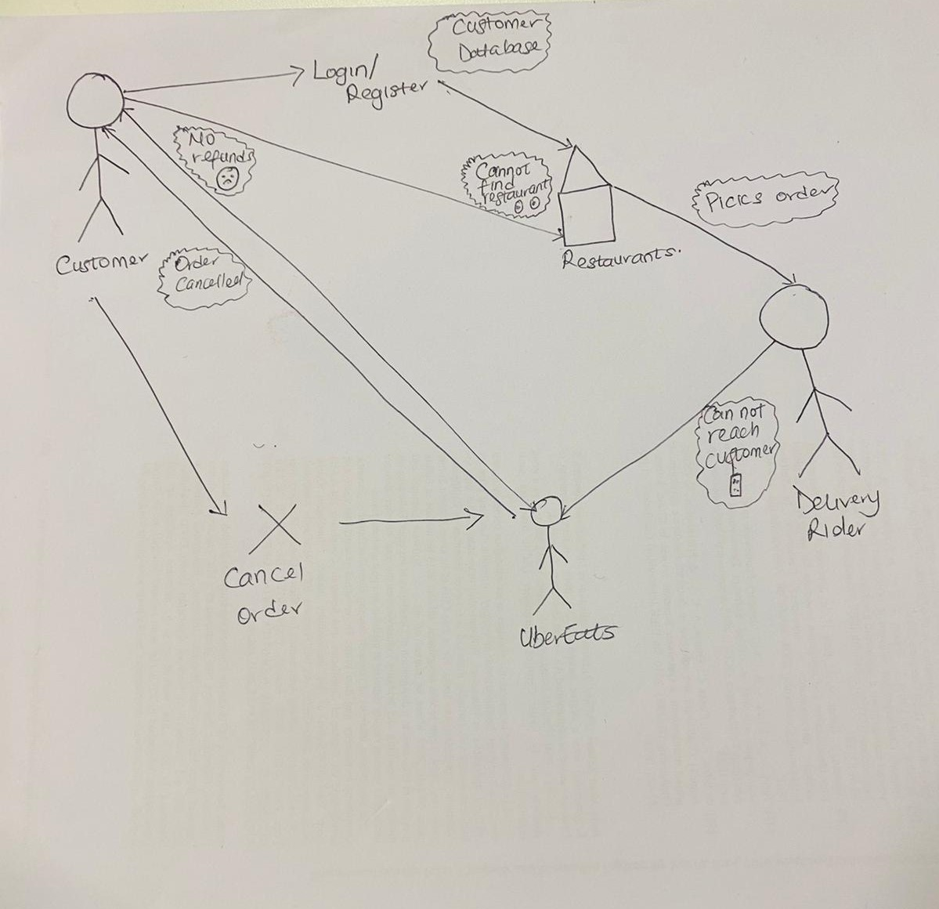

Figure 1: Rich Picture

### 4.2 DFD CONTEXT DIAGRAM

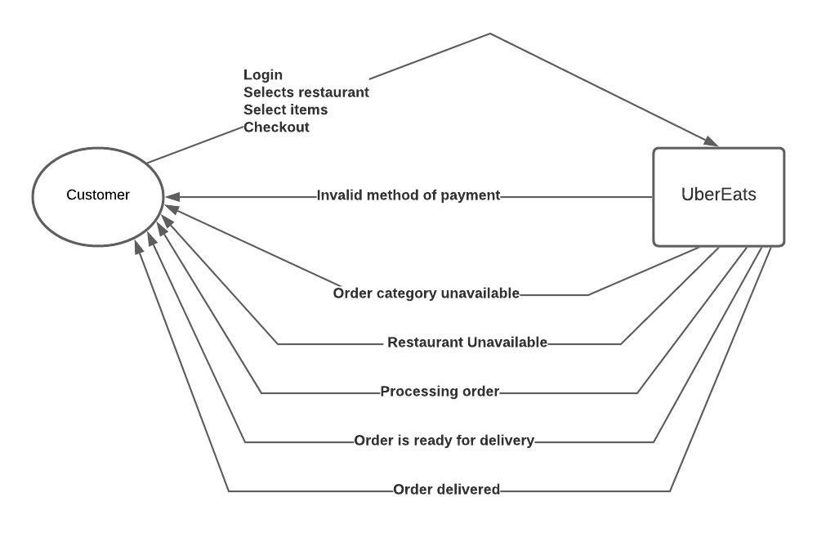

Figure 2: DFD Context Diagram

## 5.0 CONSIDER PERSPECTIVES

### 5.1 CATWOE ANALYSIS

|  |  |  |
| --- | --- | --- |
| CATWOE | USERS | INFLUENCERS |
| Customers | UberEats | Influencers |
| Actors | Restaurants  Consumers | Investors  Software and Application developers |
| Transformation | -To effectively receive customers’ orders  -To efficiently order items and have them delivered | -To provide the financial costs of the business  -To ensure that the smooth running and maintenance of the application software |
| Worldview | Satisfactory customer experience for both users. | -Profitable returns from the business  -Smooth running of the application |
| Owner | Users(Restaurant and Consumers) | Investors |
| Environment | -Availability of restaurant and meals  -Availability of riders | -Available budget  -Application glitches and errors |

|  |  |  |
| --- | --- | --- |
| CATWOE | GOVERNMENT | PROVIDERS |
| Customer | UberEats | Users, UberEats |
| Actors | Regulators | Employees(Help Desk)  Delivery riders |
| Transformation | -To ensure that the company pays all their taxes | -To ensure that complaints by the users are resolved timely  -To pick up itemsfrom the restaurant and deliver them to the consumers |
| Worldview | Business pays all their taxes | -Employees are able resolve users complaints  -Consumers receive their itemsfrom the delivery riders |
| Owner | Government | Employees, Delivery riders |
| Environment | N/A | -Unavailability of the consumer upon delivery |

Table 2: CATWOE ANALYSIS

### 

### 5.2 POWER/INTEREST GRID

**Power**

**High**

**Moderate**

**Low**

|  |  |  |
| --- | --- | --- |
| **Regulators**  **Customers** |  | **Restaurants**  **Investors** |
| **Software and Application developers** |  |  |
|  |  | **Employees**  **Delivery riders** |

**High**

**Moderate**

**Low**

**Interest**

Table 3: Power/Interest Grid

The power/interest grid above depicts the level of power and interest each stakeholder has in the business. The regulators have high power because they can shut down a business that does not pay its taxes; they have low interest in the operations of the business. The customers have high power as they should also be kept satisfied. If there is no customer, there is no business and just like the regulators, they have low interest in how the business operates. The restaurants have high power and interest as they are major constituent of the business. The software and application developers hold moderate power because they are responsible for the making sure the interface of the business is running smoothly; they have low interest because they are not an integral part of the business. The employees (customer support staff) and delivery riders have cannot control the business and as such have low power. As a key player in the business, the employees and delivery riders have high interest in the operations of the business.

## 6.0 ANALYSE NEEDS

### 6.1 STRUCTURED ENGLISH

IF promo code can be applied to on the selected restaurant

THEN customer can apply promo code on the order

ELSE

IF the restaurant does not accept promo code

THEN customer cannot apply promo code

ENDIF

IF customer cancels order before restaurant accepts the order

THEN order is cancels and customer gets a refunds

ELSE

IF customer does not cancels order before restaurant accepts the order

THEN order is cancels and customer does not get a refund

ENDIF

### 6.2 UML USE CASE DIAGRAM

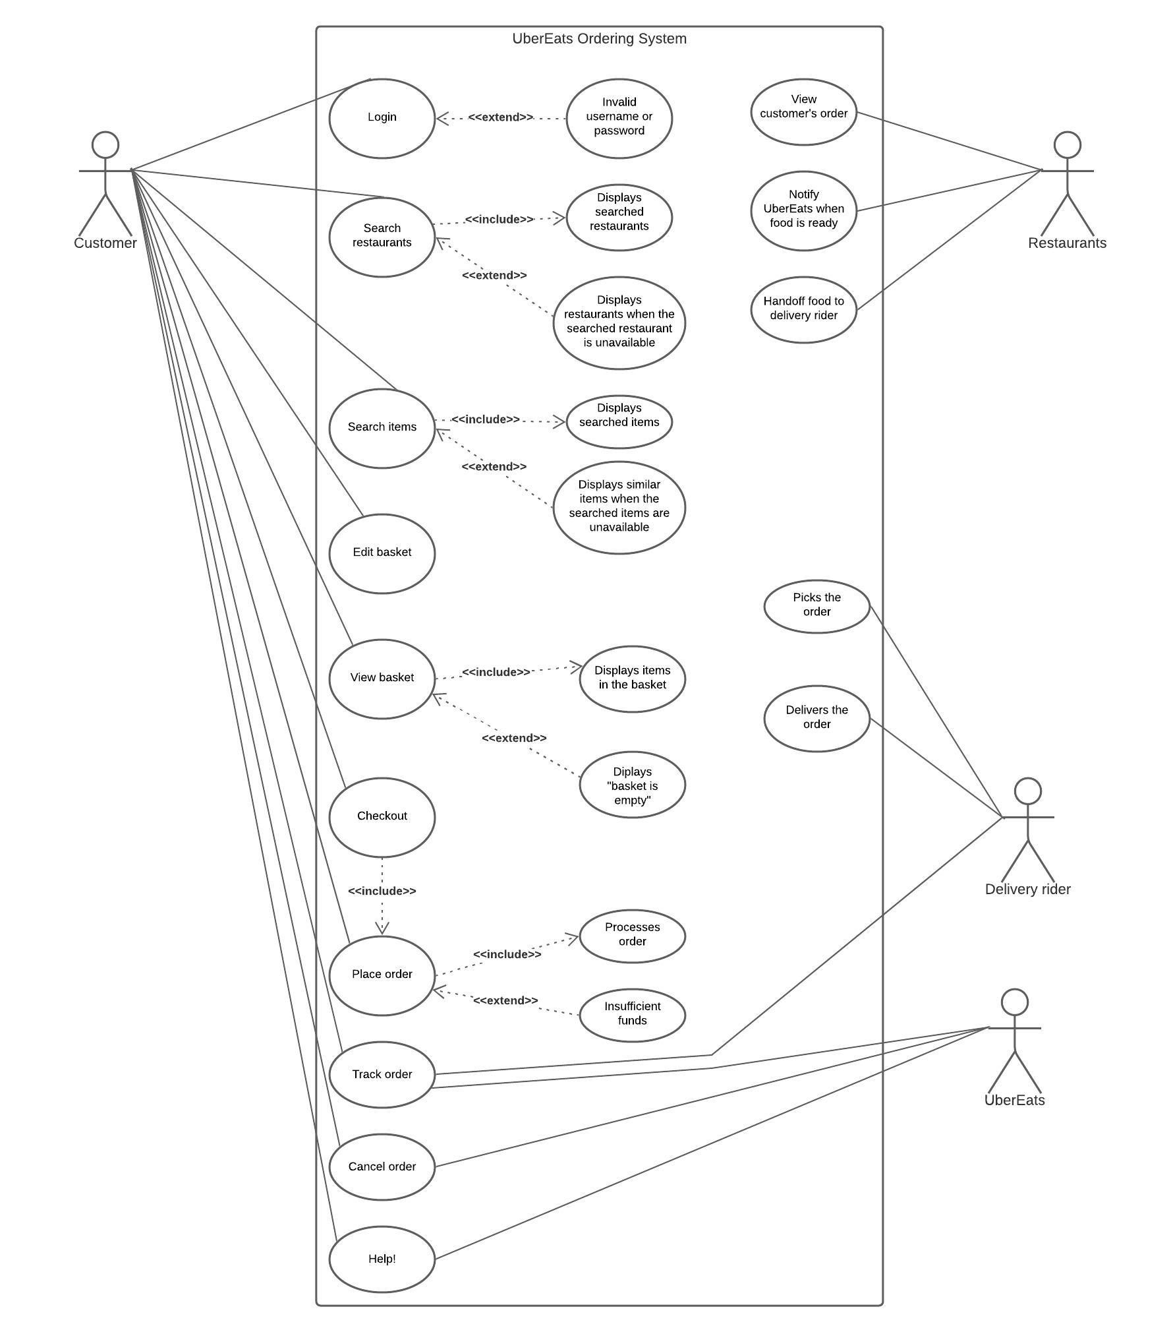

Figure 3: Use Case Diagram

### 6.2.1 USE CASE DESCRIPTION

|  |  |
| --- | --- |
| Use case | Login |
| Goal | Successful login into the UberEats app |
| Actor | Customer |
| Main success scenario | 1.Customer successfully logged into the app |
| Extensions | 1a. Customer is unregistered  1a1. System asks customer to register  1b. Customer forgot password  1b2. System asks customer to reset password |

|  |  |
| --- | --- |
| Use case | Search restaurants |
| Goal | Find a restaurant to order food from |
| Actor | Customer |
| Main success scenario | 1. Customer finds their restaurant of choice |
| Extensions | 1a. Restaurant is not on the system  1a1. System displays similar restaurants |

|  |  |
| --- | --- |
| Use case | Search items |
| Goal | Find items to order |
| Actor | Customer |
| Main success scenario | 1. Customer finds items of choice  2. System displays restaurants that have the items. |
| Extensions | 1a. Item is not on the system  1a1. System displays restaurants that have similar items |

|  |  |
| --- | --- |
| Use case | Edit basket |
| Goal | Customer can add or remove items |
| Actor | Customer |
| Main success scenario | 1. Customer edits basket successfully |
| Extensions | N/A |

|  |  |
| --- | --- |
| Use case | View basket |
| Goal | For customers to review items in the basket |
| Actor | Customer |
| Main success scenario | 1. Customer can view basket |
| Extensions | 1a. System displays basket is empty |

|  |  |
| --- | --- |
| Use case | Checkout |
| Goal | For customer to pay for their selected items |
| Actor | Customers |
| Main success scenario | 1. Customer pays for the items |
| Extensions | 1a. Customer inputs wrong card details  1a1. Systems displays wrong card details  1b. Customer has insufficient funds  1b1. System displays insufficient funds |

|  |  |
| --- | --- |
| Use case | Track order |
| Goal | For customer to trace the delivery rider with their items |
| Actor | Customer, UberEats, Delivery rider |
| Main success scenario | 1. Customer can call, text and track the delivery rider |
| Extensions | N/A |

|  |  |
| --- | --- |
| Use case | Cancel order |
| Goal | For the customer to cancel an order that has been processed |
| Actor | Customer, UberEats |
| Main success scenario | 1. Customer can cancel order  2. Customer gets a refund |
| Extensions | 2a. Customer does not cancel before restaurant accepted order and does not get a refund |

|  |  |
| --- | --- |
| Use case | Help |
| Goal | For the customer to contact customer support about queries |
| Actor | Customer, UberEats |
| Main success scenario | 1. Customer gets their queries resolved |
| Extensions | N/A |

Table 3: Use Case Description

## 7.0 DEFINE REQUIREMENTS

### 7.1 LEVEL 0 DFD DIAGRAM AND DESCRIPTION

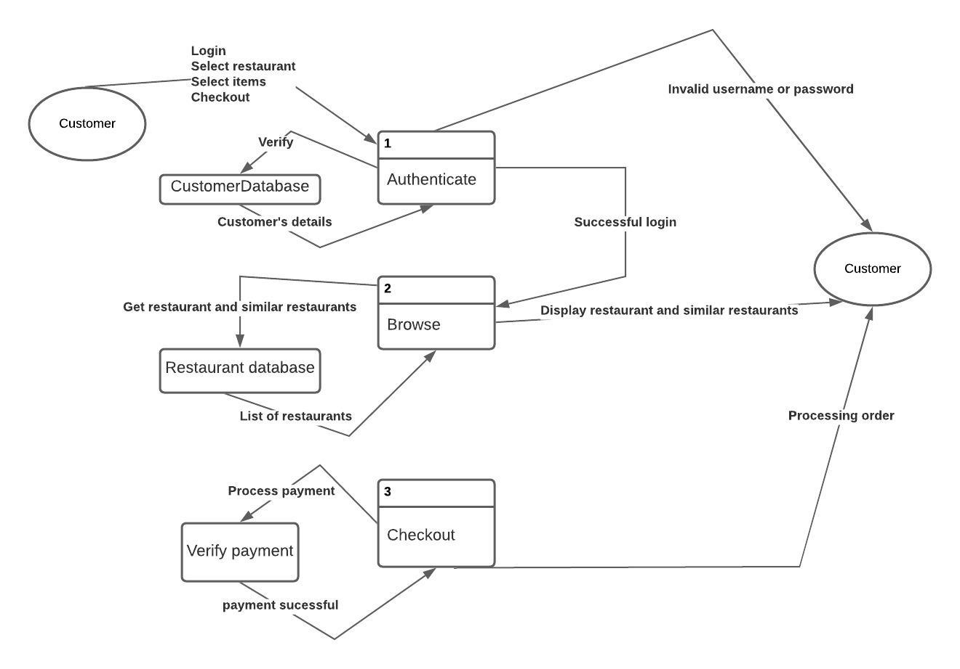

Figure 4: Level 0 DFD Diagram

### 7.2 LEVEL 1 DFD DIAGRAM AND DESCRIPTION

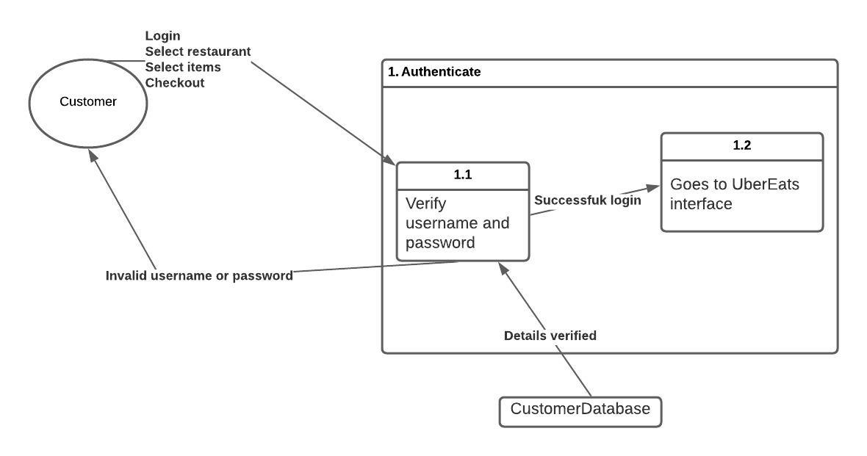

Figure 5: Level 1 DFD Diagram for Process 1

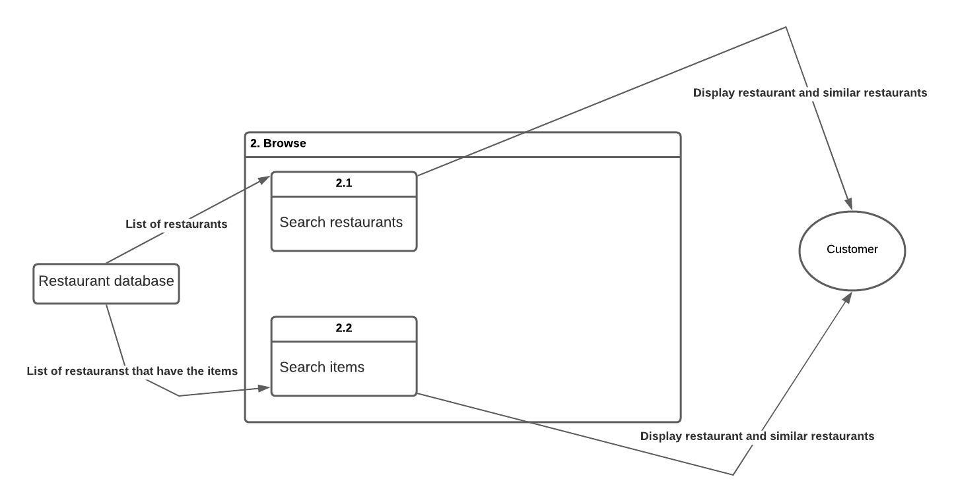

Figure 6: Level 1 DFD Diagram for Process 2

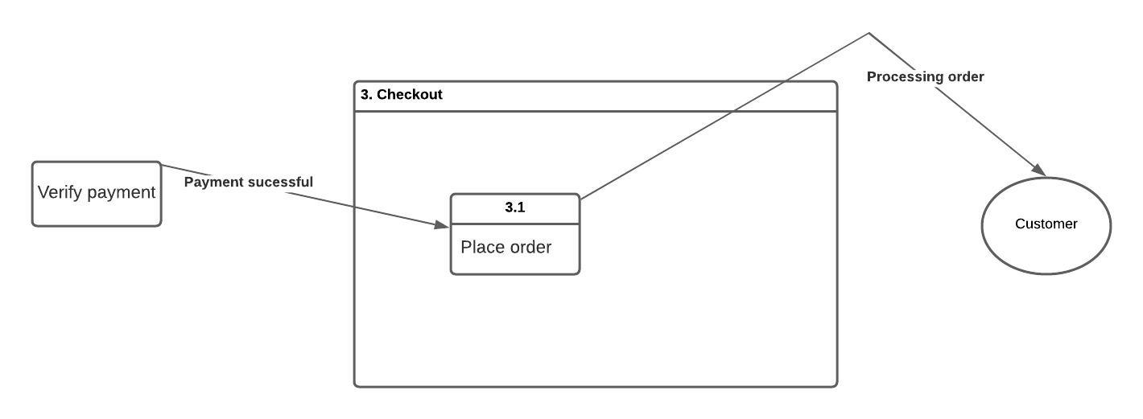

Figure 7: Level 1 DFD Diagram for Process 3

### 7.3 UML CLASS DIAGRAM

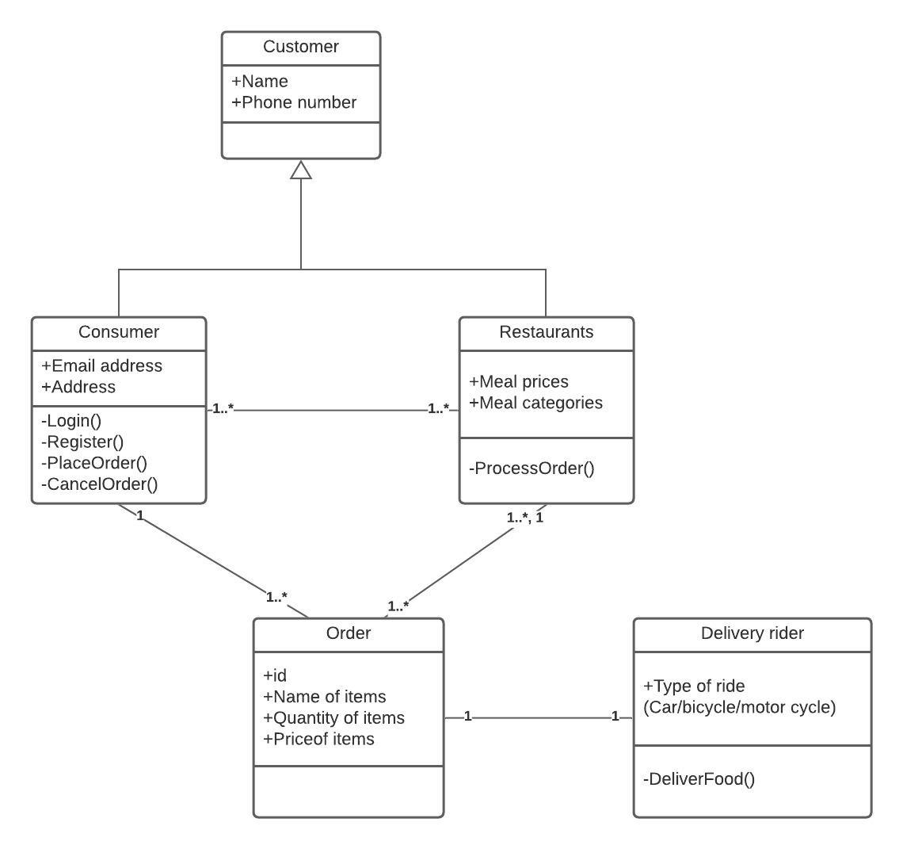

Figure 8: UML Class Diagram

### 7.4 SEQUENCE DIAGRAM

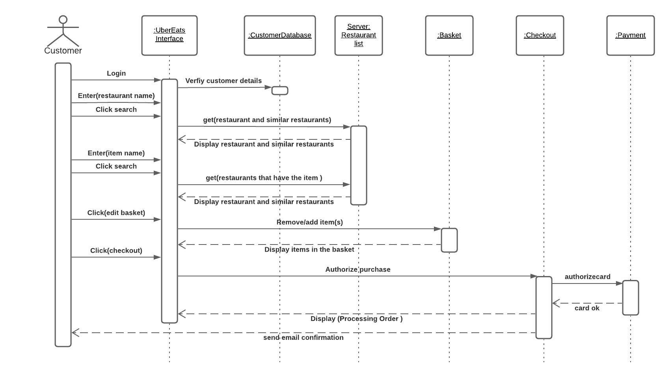

Figure 9: Sequence Diagram

## 8.0 OBSERVATIONS

From the business analysis done, it can be seen that UberEats has a system that can be referred as a high working system. UberEats is highly automated system that makes use of advanced technologies. Albeit, from the sequence diagram, it can be noticed that when a customer inputs a restaurant or items that this not available, the systems displays similar items instead of “item or restaurant not found”. This could be confusing for a new user as they the probability that they would look through the search results for what they searched for. Alternatively, the system can be configured to “item or restaurant not found” and still display the items or restaurants similar to the ones searched.

Also, from the rich picture, it can be seen that customer is worried about bot getting a refund after cancelling an order that was mistakenly placed. From the structured english for the cancellation policy, it can be seen that the customer only gets a refund if they cancel before the restaurant accepts the offer. The problem here is that it almost impossible to cancel an order after it was placed because the restaurants accept the order very quickly.

Another issue worthy of note from the rich picture is that if a delivery rider reports that they cannot contact the customer, the situation is not investigated leaving the rider to do whatever with the order of the customer and the customer is not refunded.

## 9.0 EVALUATION

Generally, I am of the opinion that the tools and techniques used in this study for UberEats business analysis are suitable and efficient. Lucid chart was used for all the visualisations in this report. It is a simple to use and very effective in depicting the requirements of the analysis.

Michael’s Five Forces Model was effective in exploring and understanding the position of UberEats in the food ordering industry. The intensities ranged between low to moderate for most of the forces with a few exceptions in competitive rivalry and bargaining power of customers which were high. The analysis is reasonably precise for UberEats because the competition in the industry is high and the barrier of entry is high, giving birth to low threats of substitute and new entrants. The resource audit elaborates one of the reasons UberEats is thriving as its good reputation and loyal clientele, this is not far from being a fact.

The rich picture provided most of the issues in this seemingly perfect system. Rich pictures aid thinking process and point out inadequacies (Bell and Morse, 2013). The rich picture helped us see the complete view of the customer. The context diagram summarized the entire input and output of the system. It outlined the interaction between the customer and the system, actions or process the customers must take (inputs) and the system outputs.

The CATWOE and Power/Interest Grid played a massive role in outlining the needs and expectations of the stockholders. These techniques aim at analysing contrasting stakeholder expectations but they showed that the most of the stakeholders at UberEats are on the same page.

Structured English, Use Case Diagram and Use Case Descriptions are powerful techniques that showed the interactions between the customer, restaurants and delivery rider within the UberEats food ordering system.

Level 0 and 1 DFD Diagrams gave massive insights and understanding to the in-depth processes within the system. The Class Diagram showed the relationship between each class and their multiplicities. For instance, a customer can order from more than one restaurant and a restaurant can receive orders from more than one customer. The Sequence Diagram captured the lifeline of the interactions between objects in a sequential order. It depicted the lifeline line of each process and activity from the customer logging in to placing their order.

# TASK 2

## INTRODUCTION

Market Basket Analysis is a technique which identifies the strength of association between pairs of products purchased together and identify patterns of co-occurrence. A co-occurrence is when two or more things take place together. MBA creates If-Then scenario rules, for example, if item A is purchased then item B is likely to be purchased.

### 1.1 ASSOCIATION RULE OF MARKET BASKET ANALYSIS

Association rules analysis is a technique to uncover how items are associated to each other. They widely used by retail store to point out strong rules identified in transaction or retail data by making use of the measure of interestingness.

### 1.2 APRIORI ALGORITHM

Apriori algorithm assumes that any subset of a frequent itemset must be frequent. It’s the algorithm behind Market Basket Analysis. Say, a transaction containing {Grapes, Apple, Mango} also contains {Grapes, Mango}. So, according to the principle of Apriori, if {Grapes, Apple, Mango} is frequent, then {Grapes, Mango} must also be frequent.

### 1.3 PARAMETERS USED IN ASSOCIATION RULES

1. **Support:** This says how popular an itemset is, as measured by the proportion of transactions in which an itemset appears.
2. **Confidence:** Say, there is a pair of items, A and B, that are frequently bought together: confidence measures how likely item B is purchased when item A is purchased, expressed as {A -> B}. This is measured by the proportion of transactions with item A, in which item B also appears.
3. **Lift**: This says how likely item B is purchased when item A is purchased, while controlling for how popular item B is. The following are the conditions for lift:

Lift (A => B) = 1 means that there is no correlation within the itemset.

Lift (A => B) > 1 means that there is a positive correlation within the itemset, i.e., products in the itemset, A, and B, are more likely to be bought together.

Lift (A => B) < 1 means that there is a negative correlation within the itemset, i.e., products in itemset, A, and B, are unlikely to be bought together.

This part of the study examines and explores an online retail database from five countries: United Kingdom, Germany, France, Eire and Spain. The aim of this study is to explore the association rules.

## APPLICATION

The first analysis on the transactions from France, there are a lot of rules to choose from as majority of the rules had high confidence. The highest lift value of 8 was between the Alarm Clock Bakelike Red and Alarm Clock Bakelike Green. When we explored further, 340 people bought the two items meaning all the people who bought the red clock bought the green clock too.

On the other hand, in Germany, there were only three rules that had lift value 4 and above. These the rules represent the strongest of all the rules in the Germany dataset. The highest value is of 6 and is between the RED RETROSPOT CHARLOTTE BAG and WOODLAND CHARLOTTE BAG. 469 people bought the former and 305 bought the latter. This implies that 305 out of the 469 people that bought the Red Retro bag also bought the woodland bag.

Meanwhile, in Spain, there are 8 rules with a lift of 11 and two out of the eight has a confidence of 1.0 which happens to be between POPPY'S PLAYHOUSE KITCHEN and POPPY'S PLAYHOUSE BEDROOM. This appears to be one of the strongest association rules from the entire dataset.

Another observation worthy of note is that the association exits between the same items but maybe different colours, styles or design. For instance, in France the association rule is between Bakelike alarm clock (red and green).

This online store can coupons and discount on items with strong association rules. This should differ as the association rules differ with location. For instance, customers in France that buy a combination of on the Bakelike Red and Green alarm clock should get discounts, customers in Germany should be discounted on purchases that include both Red Retrospot and Woodland Charlotte bag and customers in Spain should be discounted on orders containing both Poppy’s Playhouse Kitchen and Bedroom.

## 3.0 CONCLUSION

Having understanding of which products sell together is useful information to any business. Market basket analysis has other purposes such as stock inventory and product arrangement in the store.

In conclusion, the advantage of the information market basket analysis provides to a business cannot be over emphasized hence, every business selling more than two products should conduct the analysis as frequently as possible because needs and preferences are not constant.

# 

# REFERENCES

Altig, D., Baker, S., Barrero, J.M., Bloom, N., Bunn, P., Chen, S., Davis, S.J., Leather, J., Meyer, B., Mihaylov, E., Mizen, P., Parker, N., Renault, T., Smietanka, P. and Thwaites, G. (2020). Economic uncertainty before and during the covid-19 pandemic. Journal of Public Economics, 191, pp. 104-274

Osterholm, M.T. and Olshaker, M. (2020). Chronicle of a pandemic foretold the world after the pandemic. Foreign Affairs, 99 (4), pp. 10-25

Porter, M. (2008). The Five Competitive Forces That Shape Strategy. [online] Harvard Business Review. Available at: http://hbr.org/product/recommended/an/R0801E-PDFENG?referral=02154&cm_vc=rr_search_page.vertical [Accessed 28 April 2021].

Johnson, G., Scholes, K., Whittington, R. (2008). Exploring Corporate Strategy (8th Edition). Financial Times Prentice Hall.

Woods, E., and Rozanski, N. (2009). The System Context Architectural Viewpoint. 333 - 336. 10.1109/WICSA.2009.5290673.

Bell, S., and Morse, S. (2013). How People Use Rich Pictures to Help Them Think and Act. Systemic Practice and Action Research.

Adler, J. (2012). R in a Nutshell, 2nd Edition